Battleship: An Augmented Reality Training Experience

**The Team**

|  |  |  |  |
| --- | --- | --- | --- |
| IMG_5355.jpg | meera.jpg |  | IMGFORCAPSTONE.png |
| Kirsten Bauman | Meera Benson | Michaela Foote | Makayla Menges |

**Project Description**

The tech world is all abuzz about the potential of virtual reality and augmented reality. However, do we stop to think about how these technologies affect the user experience of their content? We want to look into how augmented reality (AR) affects people’s experience of the content they are consuming. More specifically, we want to look at the gaming experience. We ask: what is the best use for AR? What kind of information can it give us? How does it affect the user’s gameplay? What is it’s best implementation in a game? What is the compelling need for AR in gaming?

This topic is interesting to us because AR has the potential to be the next big computing platform. While virtual reality completely immerses the user in a virtual world, augmented reality overlays digital imagery over a user’s view of the real world. Users don’t need special devices; simply having a smartphone allows you to experience AR in the palm of your hands. With this being said, AR has the potential to completely change the way we go about our lives. The main goal of our capstone project is to delve into this emerging industry and create a usable and fun product. We hope to show that AR is a promising platform for gaming by creating an augmented reality game, using Apple’s new ARKit or Vuforia, based on the classic board game Battleship and comparing the user experiences of players. Since AR is a new technology, this game could be an easy introduction into AR and to potentially train users in AR skills such as fine grain placement.

**Project Mockup**

**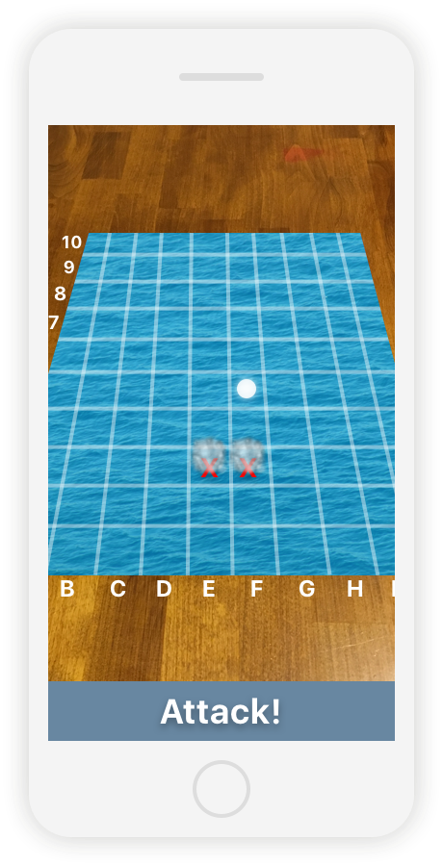 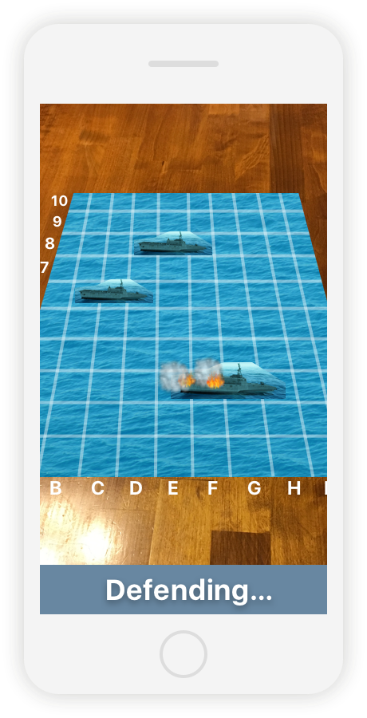**

Player Attack View Player Defending View

**Timeline**

|  |  |
| --- | --- |
| **Week** | **Goals** |
| Sep 18 -24 | Establish the gameplay of app, create user workflows |
| Sep 25 - Oct 1 | Start creating assets |
| Oct 2 - 8 | Layout app architecture, complete wireframes |
| Oct 9 - 15 | Continue app production, Finish asset creation |
| Oct 16 - 22 | Continue app production |
| Oct 23 - 29 | Have working prototype, start testing |
| Oct 30 - Nov 5 | Present at private AME showcase |
| Nov 6 - 12 | Work on bugs/enhancing UX |
| Nov 13 - 19 | Work on bugs/enhancing UX |
| Nov 20 - 26 | Work on bugs/enhancing UX |
| Nov 27 - Dec 3 | Present at public AME showcase, complete final documentation |